**Module-6: Case Study**

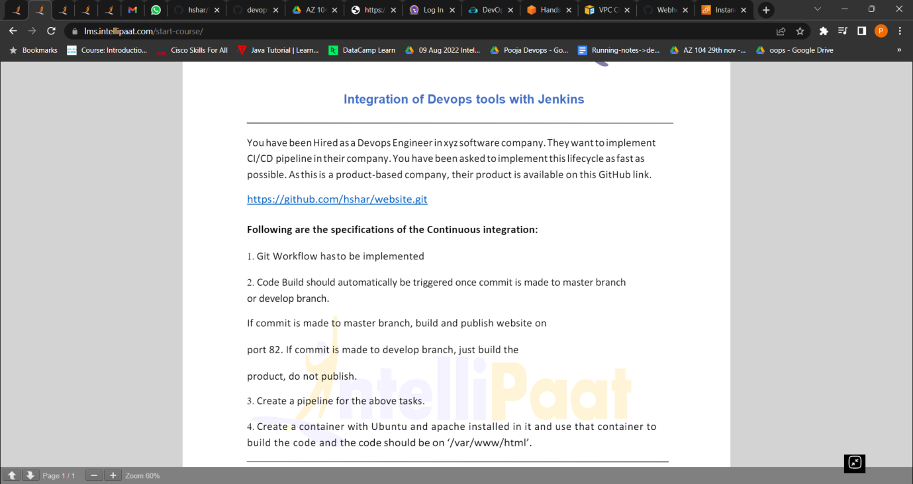

1. Git Workflow hasto be implemented.
2. First fork the git repository
3. Clone it in our own local system
4. Git workflow will be implemented

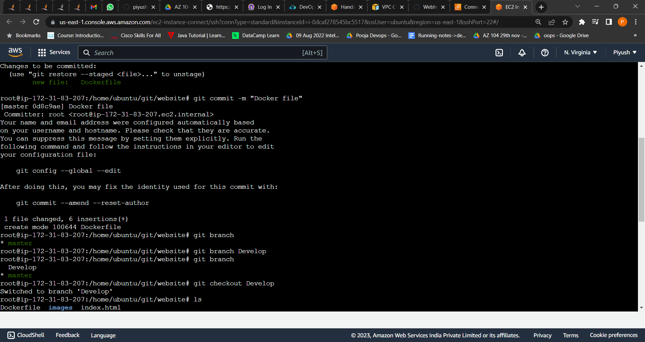

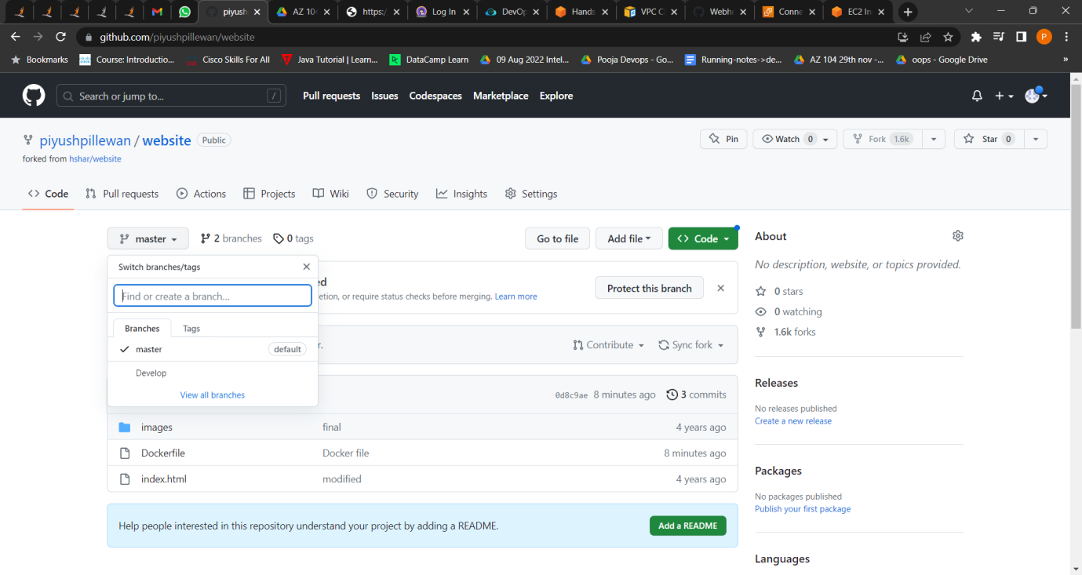

1. Code Build should automatically be triggered once commit is made to master branch or develop branch. If commit is made to master branch, build and publish website on port 82.

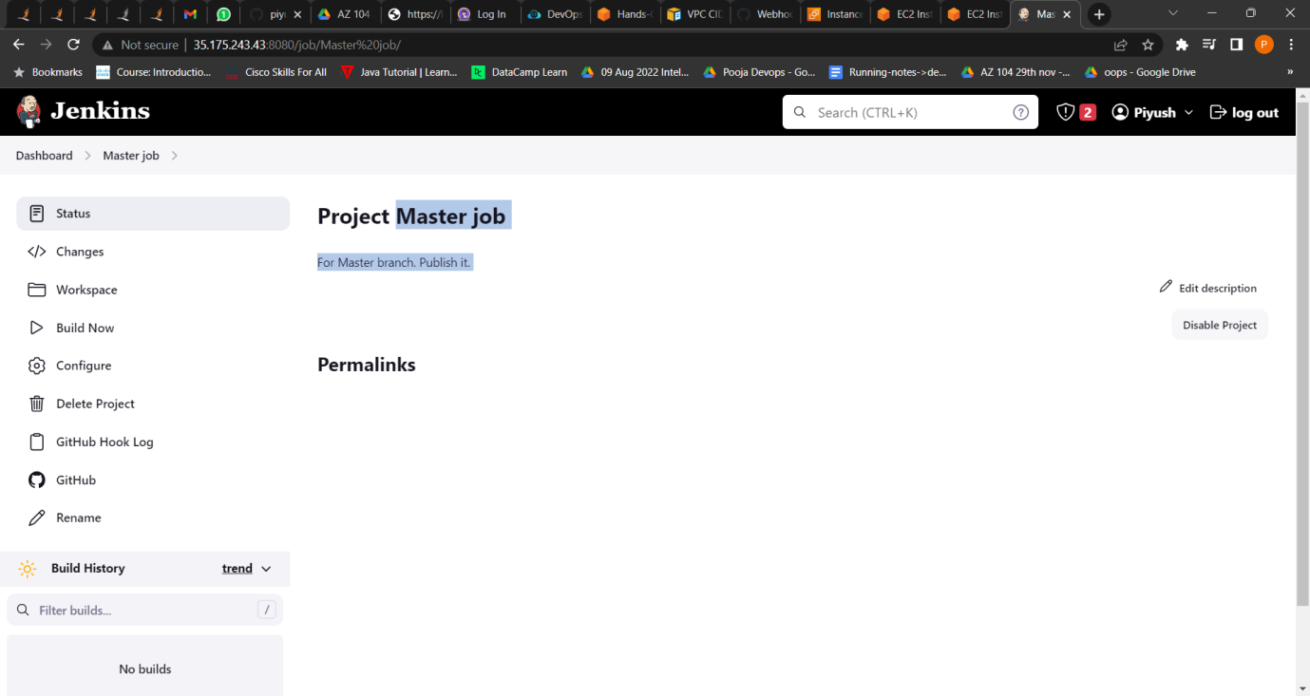

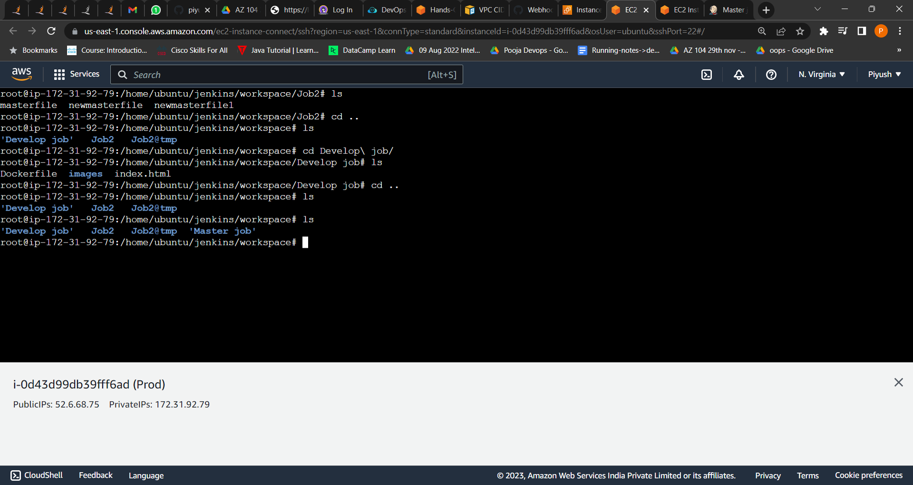

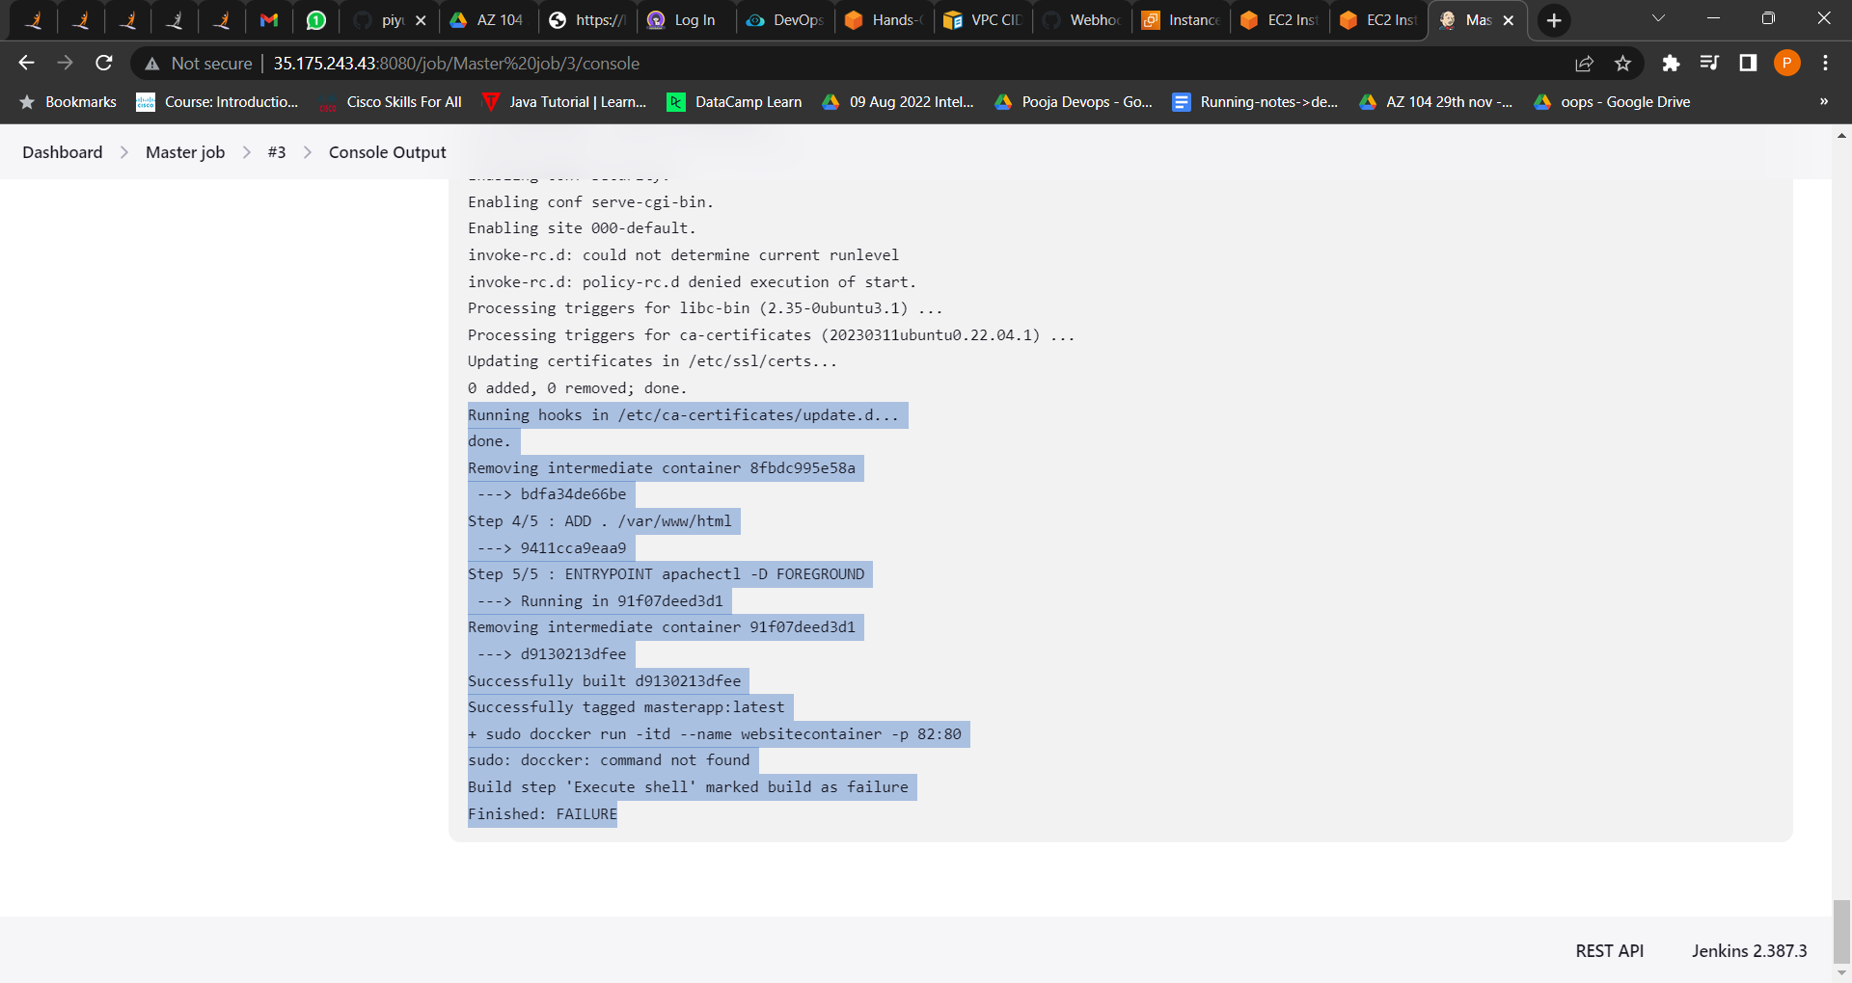

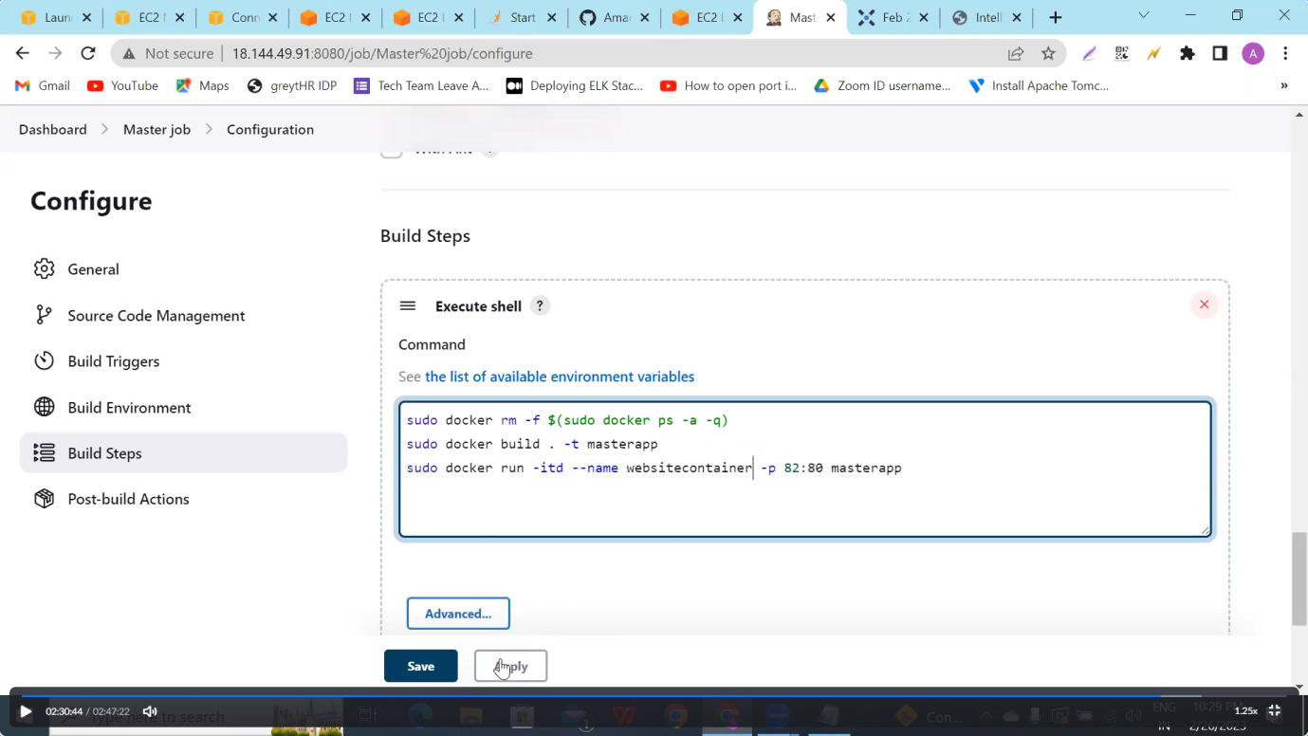

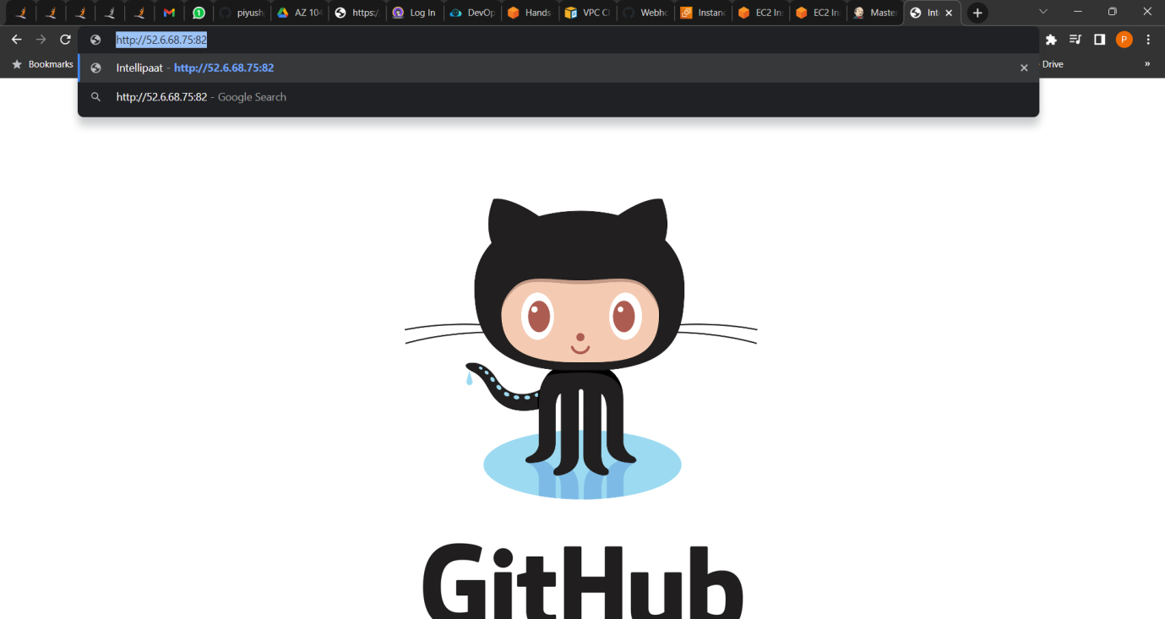

If commit is made to develop branch, just build the product, do not publish.

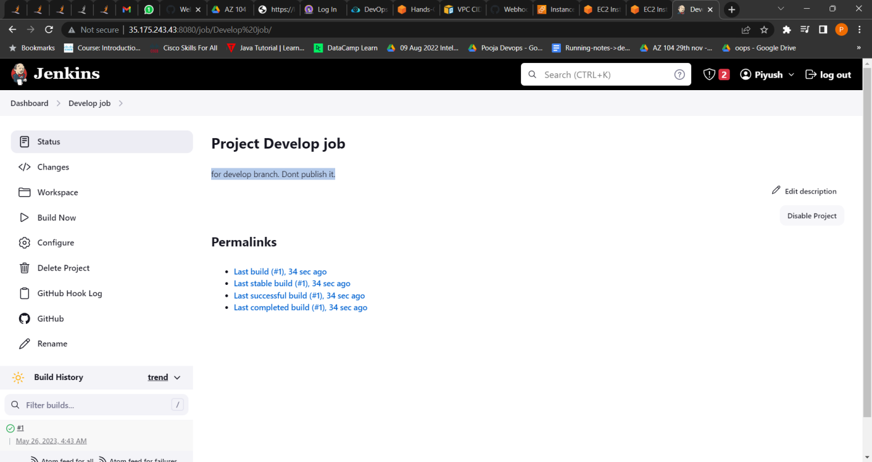

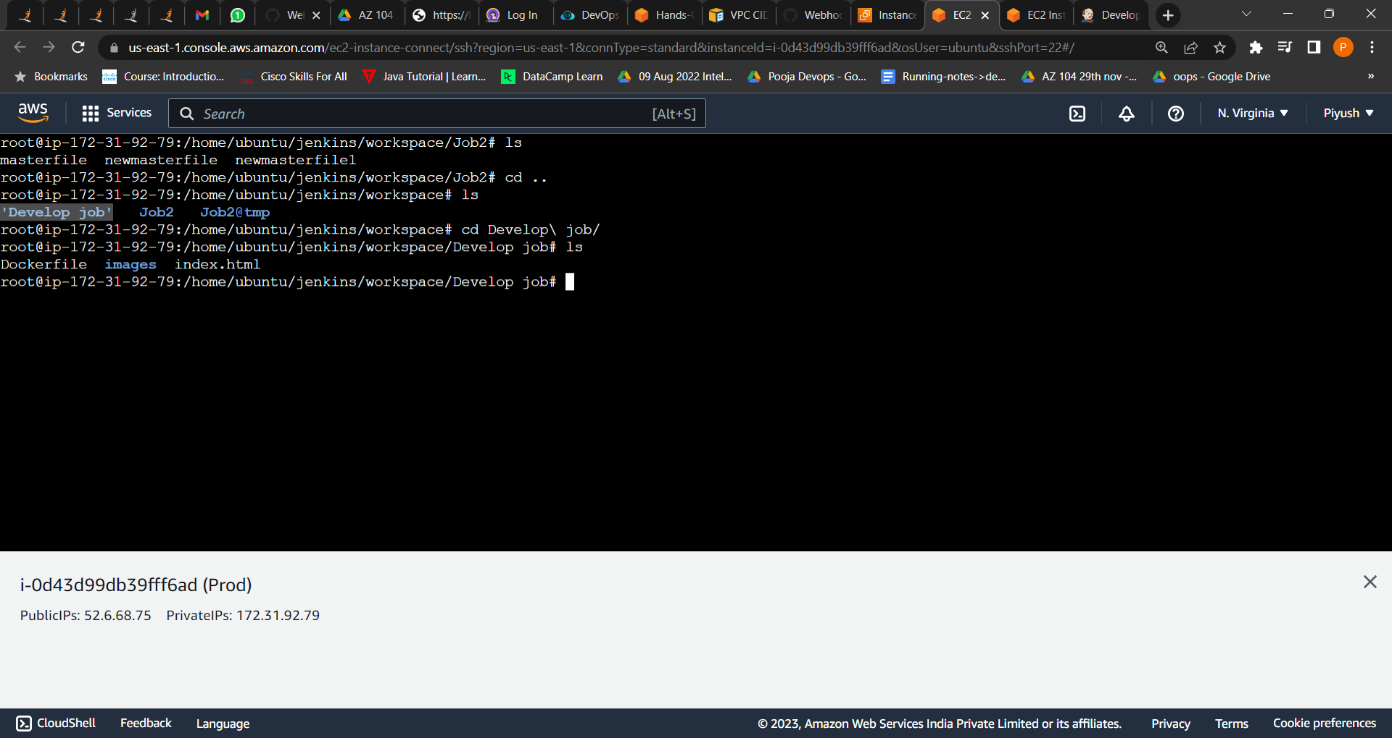

1. Create a pipeline for the above tasks.

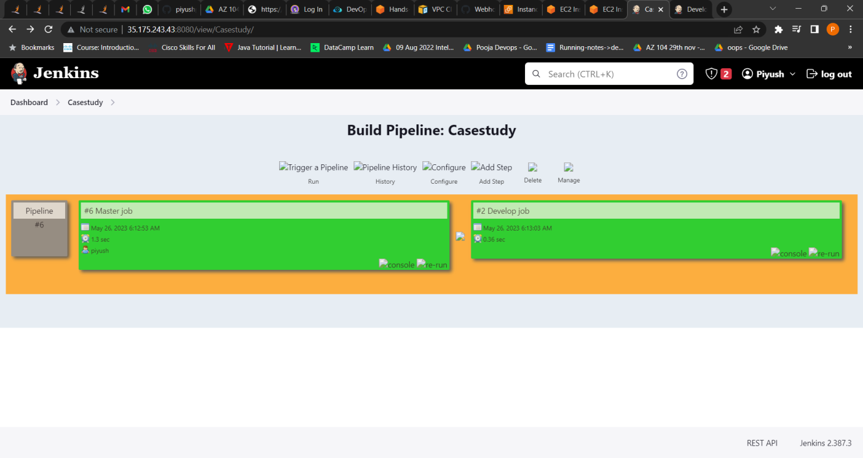

1. Created a container with Ubuntu and apache installed in it and used that container to build the code and the code should be on ‘/var/www/html’.



